Guided Capstone Project Report

I wrote in the last report that I would do both scenarios 1 and 2, but after doing some research, I learned that customers [don’t respond to price drops in all markets](http://www.marketingmo.com/strategic-planning/will-lowering-your-prices-increase-profits/). Also, it’s difficult to enact two plans at the same time. What if they interact with each other? What if the run newly released becomes too unpopular in year 1 so it gets removed in year 2? That’s why I chose to go with scenario 2 (adding a run, increase of 150 feet vertical drop, and a new chairlift), with a price increase.

A price increase is justified by the random forest model. The modelled price is $95.87 with a mean absolute error of $10.39. This means that the modelled price could be $95.87, give or take $10.39. This model isn’t perfect, in fact, it does not even consider operating costs of the resort. Looking at the weekend ticket price across the US, Big Mountain Resort is about “in the middle” of the graph.

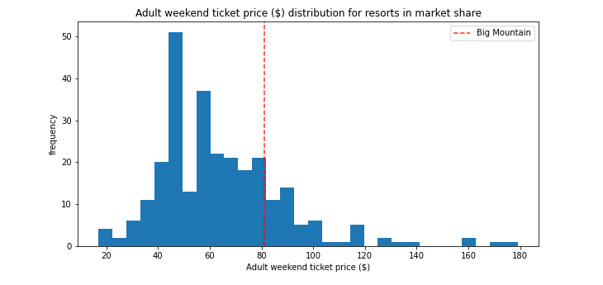

A bit of price increase is justified, but how much? To answer that question, we turn back to the ski data from exploratory data analysis step and change some values of the features. This includes adding a run, adding a chairlift, and adding 150 feet to their respective features. We assume that a visitor will buy an average amount of tickets, which is 5. We also assume with can expect 350,000 visitors again. Running some math with those changes, we get that scenario 2 adds $1.99 support for ticket price. This means raising the ticket price $2 after installing the new run, chairlift, and higher vertical drop is justified by that math from earlier. This would earn Big Mountain Resort an additional $3,474,638 during the season, assuming the 5 tickets and 350,000 visitors. Given the last chair lift cost about 1.5 million in costs over the season, this should be plenty to cover those 3 features.

If a customer asks why the price has gone up, you now have justification. Scenario 1 is an option to consider for later, but I would wait until the new run is established for a while before removing any runs.